**Block Level Designs**

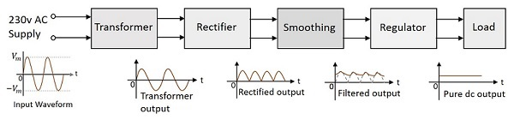The main blocks of a linear power supply are as follows,

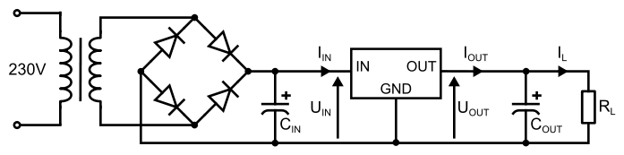

We are given a 230V to 15V transformer the peak value of the secondary winding $V_{PSec}$ is around 21.2V. We are using full-wave bridge rectification for the rectification. Here we should consider the Peak-Inverse-Voltage (PIV) of each diode. Since the reverse-biased voltage can go up to ( $V_{pSec}-0.7)V$ (Here we assume forward biased voltage across a diode as $0.7V$. Since it can vary, we should double-check diodes before assuming such voltages), the diodes we choose should have a PIV above $19.5V$.

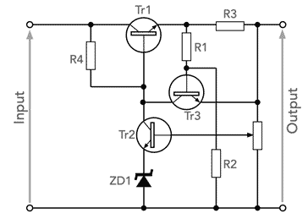Next, we may use smoothing capacitors to smooth the voltage and reduce the ripple factor. Ripple voltage can be calculated from the following equation,

$$V_{ripple}=\frac{I_{load}}{2fC}$$

Since we have a rectified voltage wave at this point, we can regulate it and get a good DC output at the load. We can consider the current limiting of the circuit here and have circuitry for regulation with current limiting as to the figure shows.

We can limit the maximum current by the equation,

$$I_{max}=\frac{1}{R_{3}}(\left(1+\frac{R_{1}}{R_{2}}\right)V_{BE}+\frac{R_{1}}{R_{2}}V_{reg}$$

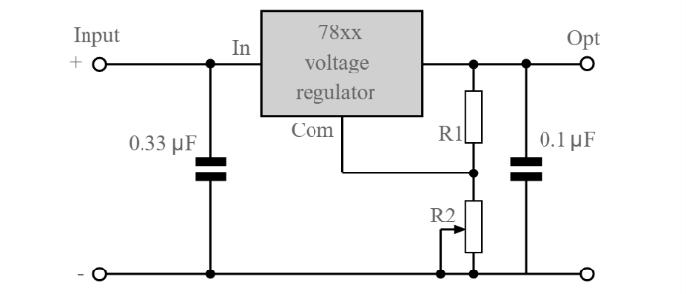Since 78xx series voltage regulators are commonly used for voltage regulation, we can consider using them for the regulation as well. We can get variable voltage output from these ICs by just adding extra two resistors. The output voltage can be calculated by the equation,

$$V_{out}=V_{XX}+(\frac{V_{XX}}{R_{1}}+I_{o})R_{2}$$

$$V_{XX}=voltage of the regulator,{ I}_{o}=current in the common line$$